Exp.No-8

8. Scaling an image to its bigger and smaller sizes.

Aim:
To resize (scale) an image using OpenCV.

Procedure:
- Start the program.
- Import the OpenCV library.
- Read the input image.
- Resize the image to a larger size.
- Resize the image to a smaller size.
- Display the original, enlarged, and reduced images.
- Save the resized images.
- Stop the program.
Program:
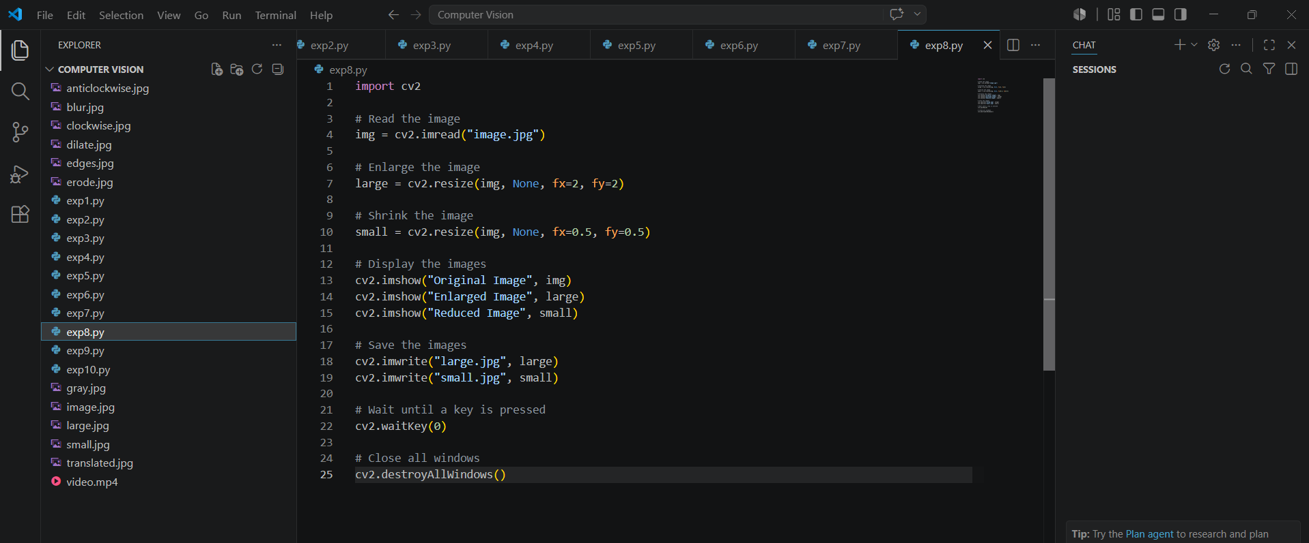

Input:
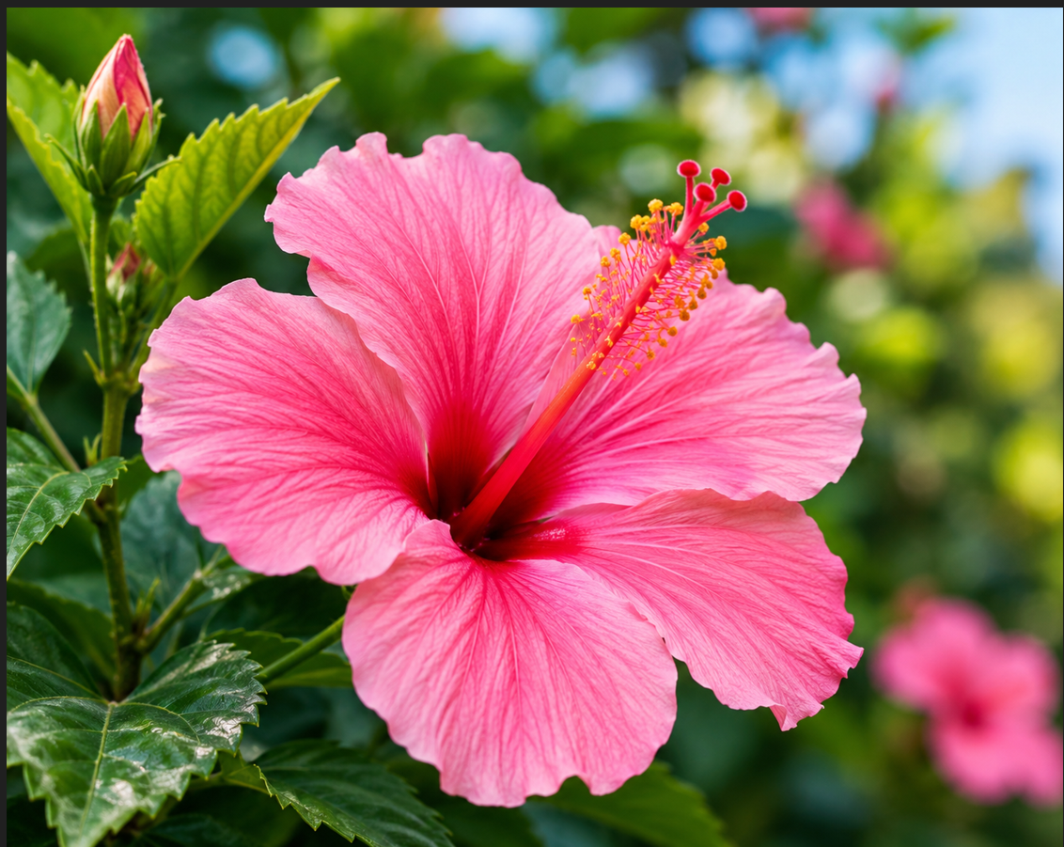

Output:
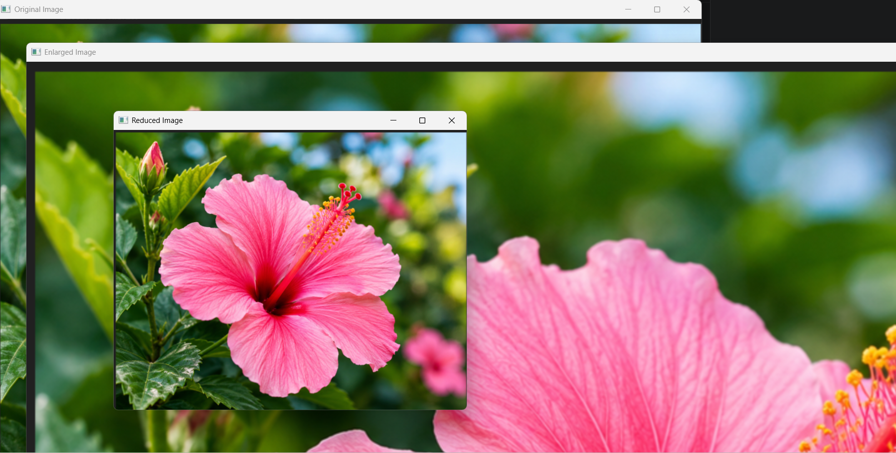
Result:
The input image was successfully enlarged and reduced using image scaling.

